**Manual Documentation for Name Sorter Application.**

1. To Execute the application Run “CMD” command in Windows Start Up menu.
2. In the Command Prompt change the directory to “bin” directory of NameSorter App,

And then access directory “debug” then “Net48”, and you can find the NameSorter.exe .

1. Executing the apps is by typing “NameSorter” in command prompt.
2. Then the standard view should be look like this

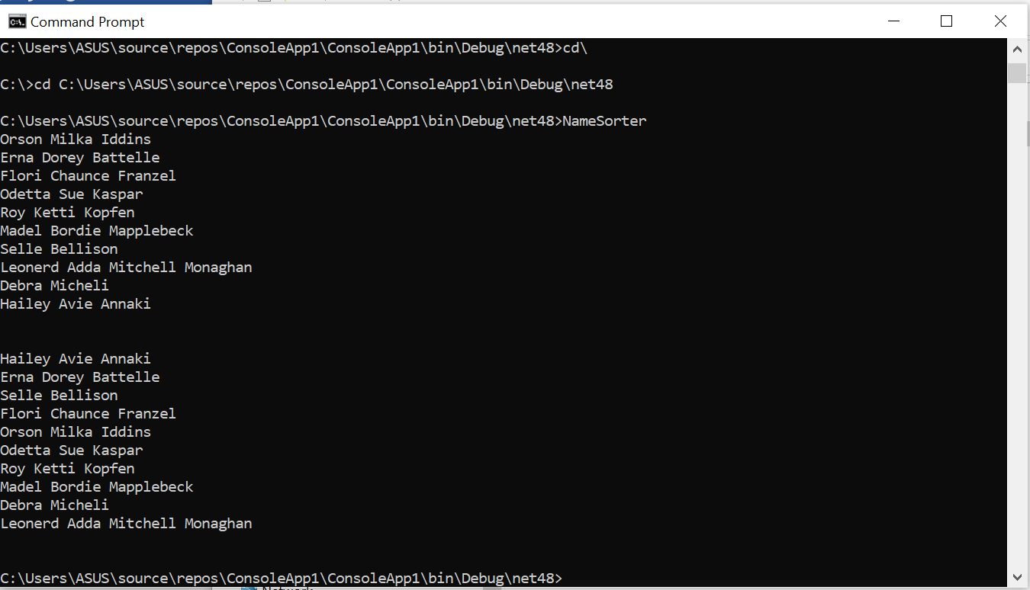

1. Please note that to be able to run the application properly, you need to have .NET version 4.8 framework installed in your computer.